**Sustainable Smart City Assistant using IBM Granite LLM**

Team ID : LTVIP2025TMID38464

Project Name : Sustainable Smart City Assistant Using IBM Granite LLM

**1. INTRODUCTION**

**1.1 Project Overview**

The **Sustainable Smart City Assistant** is an AI-powered civic engagement platform that integrates generative AI (IBM Granite LLM) with municipal data to enhance urban governance. Built using **Streamlit** and **FastAPI**, it provides modules for policy summarization, citizen feedback sentiment analysis, KPI forecasting, anomaly detection, and eco-friendly tip generation.

**1.2 Purpose**

The project aims to bridge the communication and information gap between citizens and urban administrators. By enabling personalized and intelligent interactions, the system supports sustainable decision-making and real-time engagement using AI-driven insights.

**2. IDEATION PHASE**

**2.1 Problem Statement**

Urban stakeholders lack AI-powered tools to interpret large volumes of policy documents, manage feedback efficiently, detect anomalies in civic data, and guide citizens with sustainable actions.

**2.2 Empathy Map Canvas**

* **Users:** Citizens, Government Officials (Admins)
* **Needs:** Simplified policy understanding, transparent feedback mechanisms, real-time data analytics
* **Pains:** Overwhelming information, delayed responses, lack of personalized communication
* **Gains:** AI-generated summaries, feedback insights, daily eco tips, anomaly alerts, and improved service delivery

**2.3 Idea Pool (Brainstormed Concepts)**

* AI-based policy summarization using Granite LLM
* Sentiment analysis of citizen feedback
* KPI forecasting dashboard
* Real-time anomaly detection for urban utilities
* Personalized daily eco tips
* Chat assistant for answering civic queries

**3. REQUIREMENT ANALYSIS**

**3.1 Customer Journey Map**

1. Citizen/Admin logs in
2. Citizen submits feedback or asks queries
3. Admin uploads policies or reviews dashboards
4. System generates summaries, tips, forecasts, or anomaly alerts
5. Users view insights on personalized dashboards

**3.2 Solution Requirements**

* IBM Granite LLM integration
* Streamlit-based dashboards
* FastAPI backend with role-based routing
* Feedback NLP engine & policy summarization
* Real-time KPI forecasting and anomaly detection
* Daily tip generation using prompt templates

**3.3 Data Flow Diagram**

1. User input → API Gateway → Granite LLM → Output (Summaries, Tips, Responses)
2. Feedback/Policy/KPI data → Analysis → Dashboard Visualization
3. Stored results → JSON/Cloud for further insights

**3.4 Technology Stack**

* **Frontend/UI:** Streamlit
* **Backend:** FastAPI, Python
* **AI Model:** ibm/granite-3-3-8b-instruct (Hugging Face)
* **Database:** JSON-based or optionally MongoDB/Firebase
* **Libraries:** Transformers, Pandas, Matplotlib/Plotly, scikit-learn, NLTK, SpaCy

**4. PROJECT DESIGN**

**4.1 Problem–Solution Fit**

Traditional smart city dashboards provide only static insights. This assistant uses real-time AI to summarize documents, analyze feedback, forecast key metrics, and improve urban sustainability.

**4.2 Proposed Solution**

A modular civic assistant featuring:

* **Policy Summarizer**: Converts long policies into plain summaries
* **Feedback Analyzer**: NLP-driven insights into citizen satisfaction
* **KPI Dashboard**: Forecasts key indicators (water, traffic, energy, etc.)
* **Anomaly Detector**: Flags unusual patterns
* **Eco Tips Engine**: Generates daily sustainability recommendations
* **AI Chat Assistant**: Answers citizen queries

**4.3 Solution Architecture**

* **UI Layer**: Streamlit Web App
* **AI Layer**: IBM Granite LLM via Hugging Face
* **API Gateway**: FastAPI with secure routing
* **Storage**: JSON/Flat File or NoSQL
* **Visualization**: Plotly, Pandas
* **Vector Search (if used)**: Pinecone for semantic retrieval

**5. PROJECT PLANNING & SCHEDULING**

**5.1 Project Planning**

* - Week 1-2: Ideation and Design - Week 3-4: Model Integration and Content Generation - Week 5-6: UI and Dashboard Development - Week 7: Testing and Documentation

**6. FUNCTIONAL AND PERFORMANCE TESTING**

**6.1 Performance Testing**

* Tested quiz generation and model response time. IBM Granite model loads efficiently using GPU. Quiz generation is ~5s on average.

**Output Screenshots:**

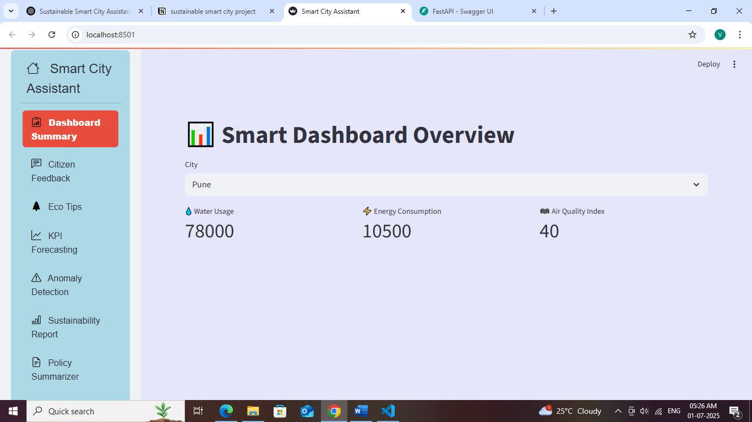

**Fig: Main Dashboard**

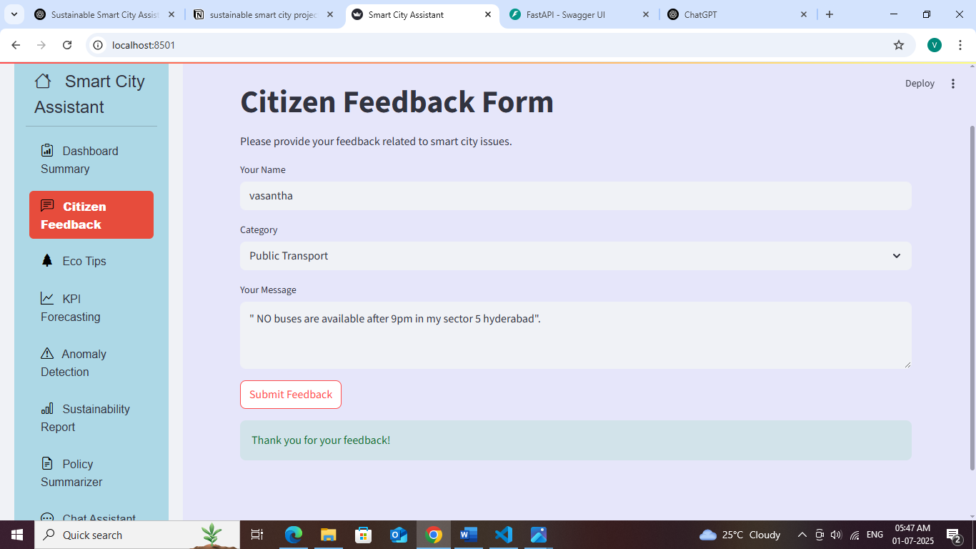

**FIG : Citizen Feedback**

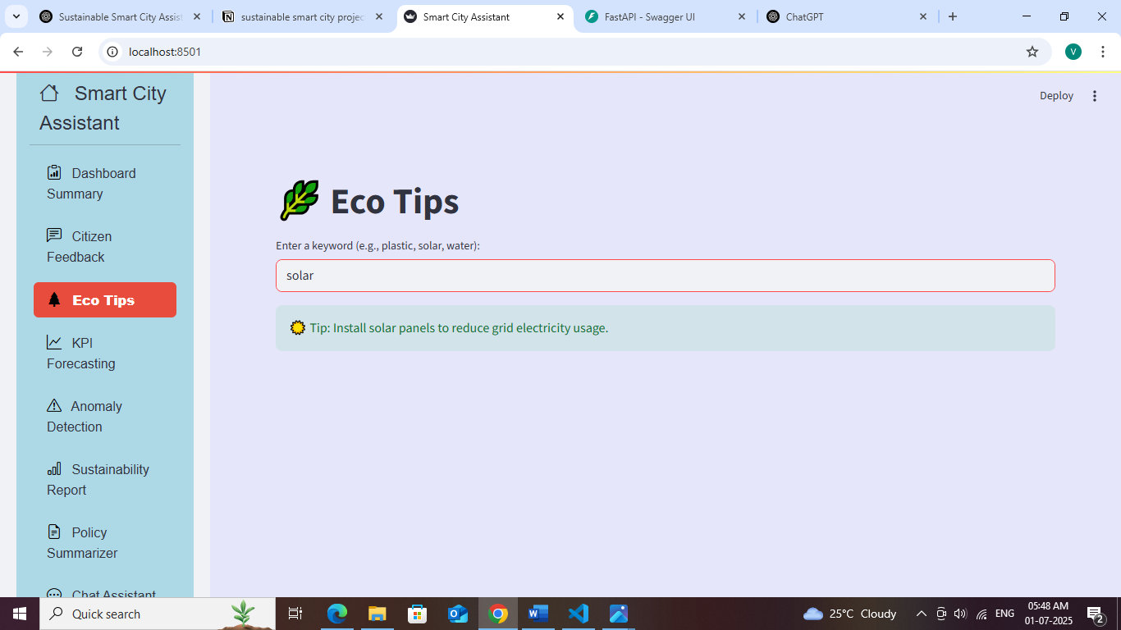

**Fig: Eco Tips**

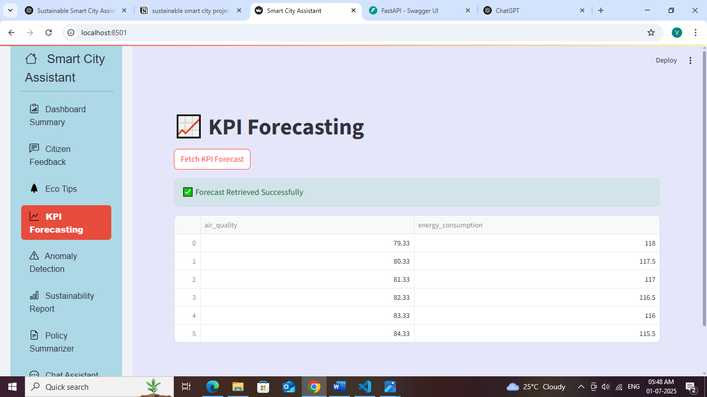

**Fig:KPI Forecasting**

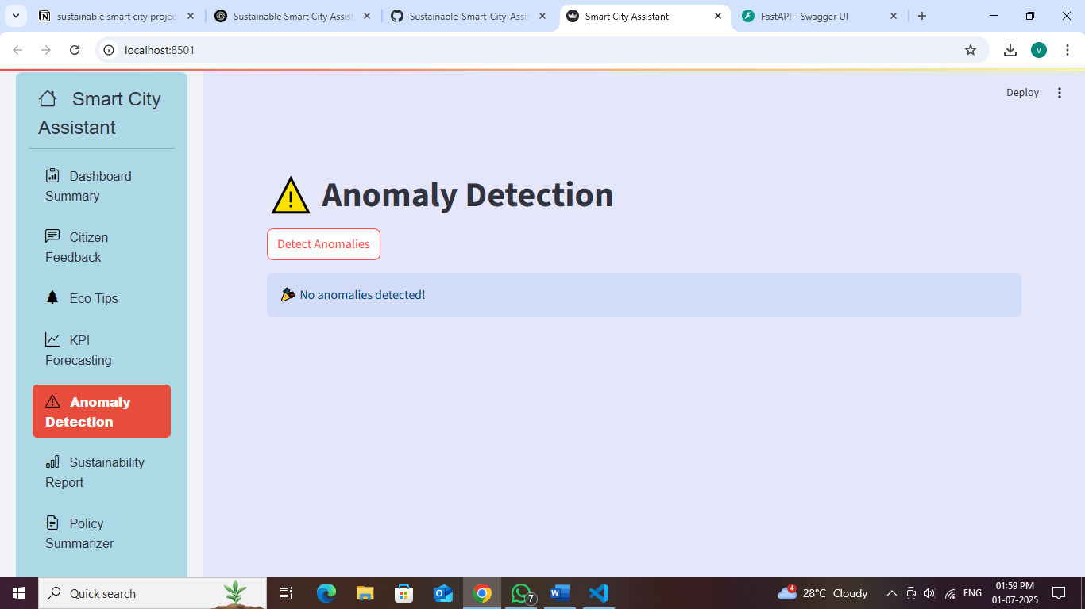

**Fig:Anomaly Detection**

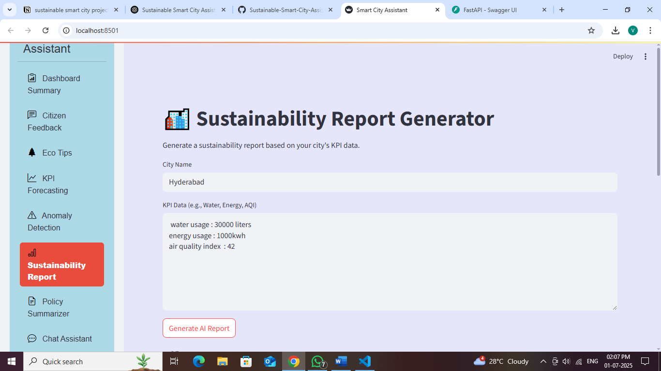

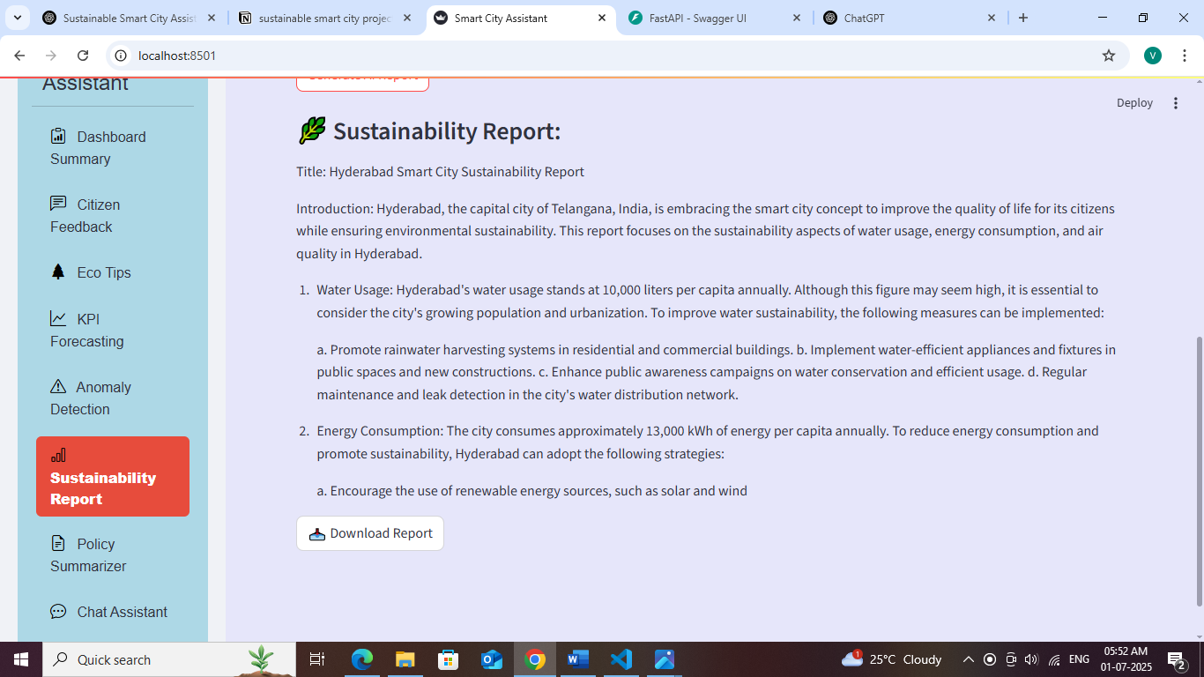

**Fig:Sustainability Report**

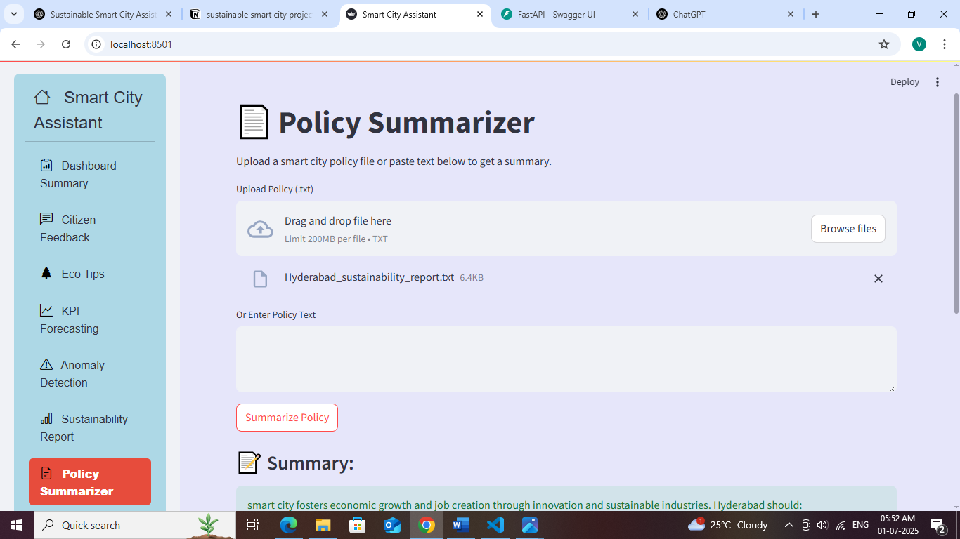

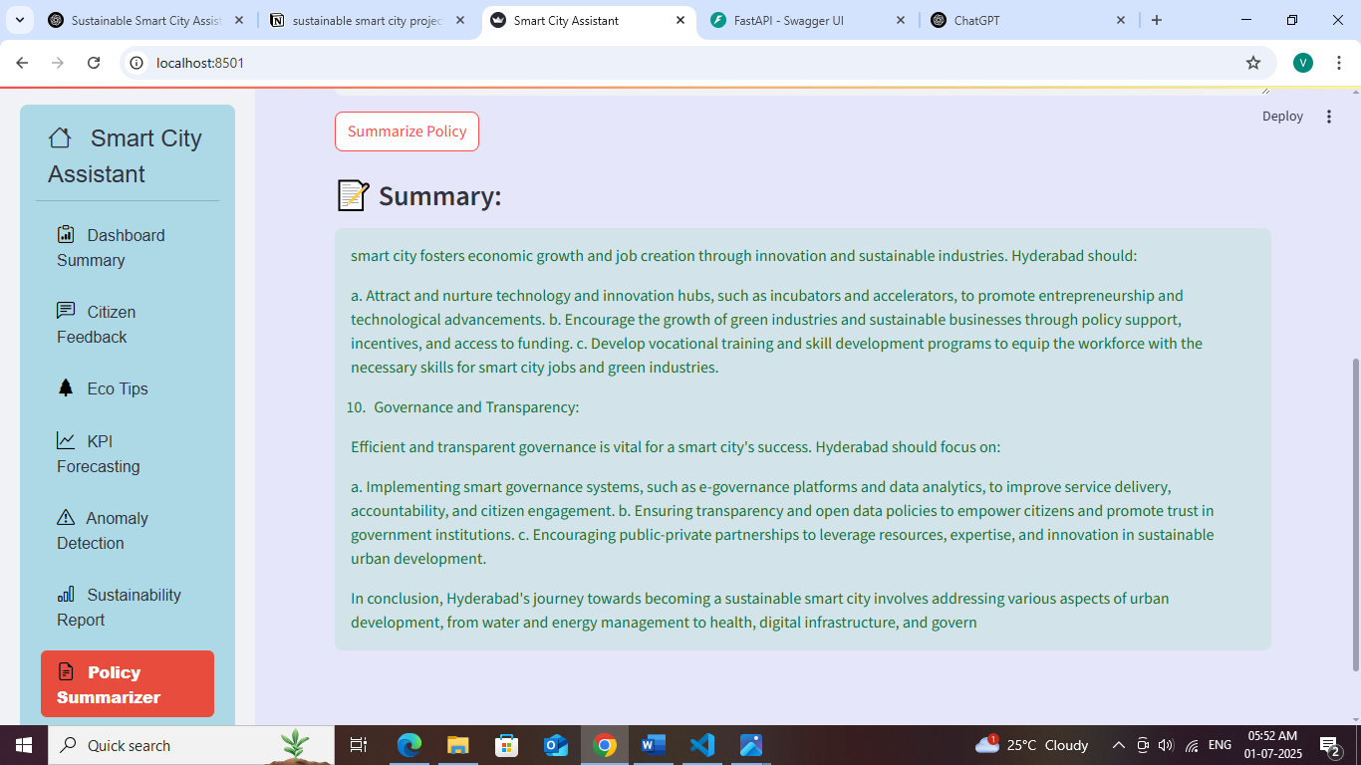

**Fig: Policy Summarizer**

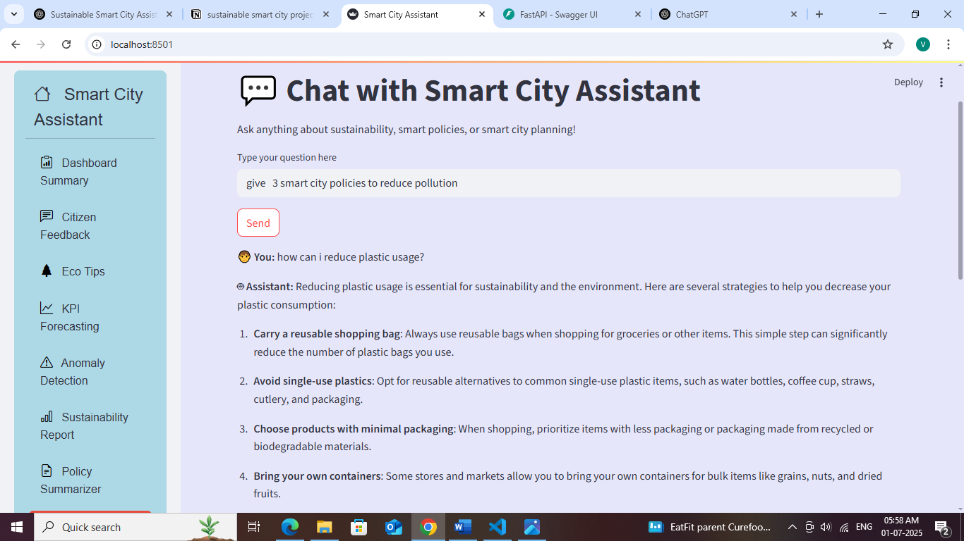

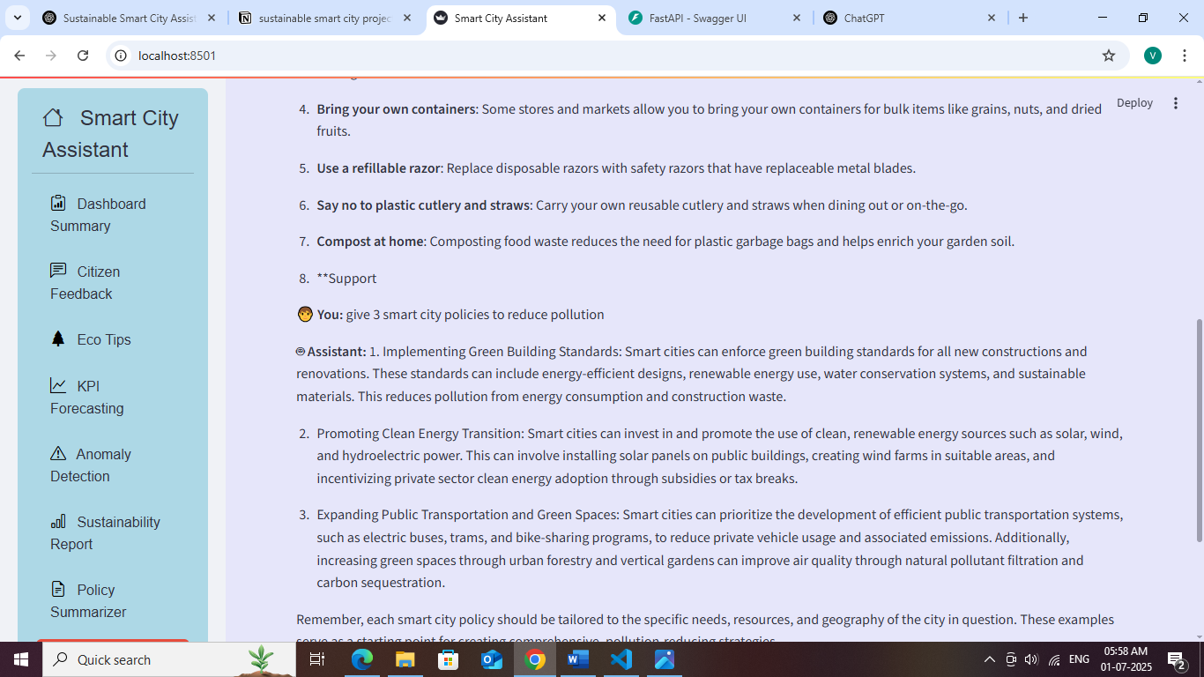

**Fig:Personalized Assistant**

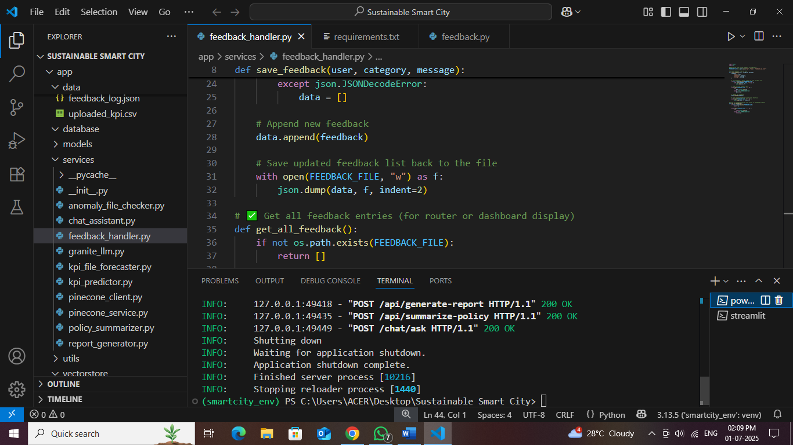

* **Code Execution**

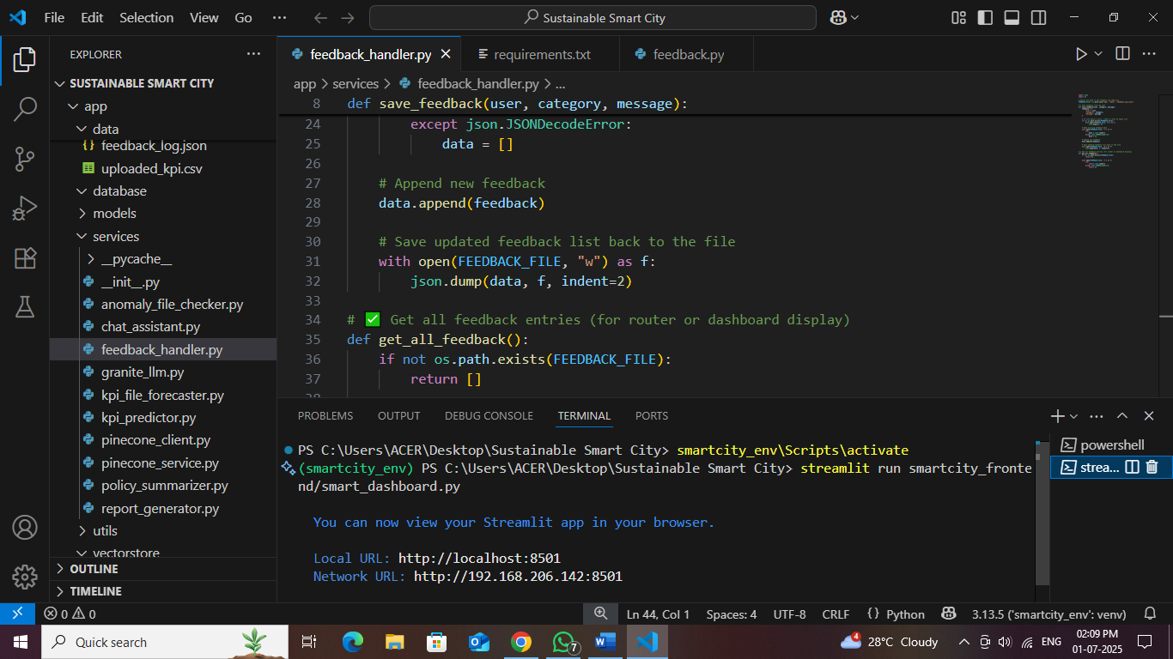

**8. ADVANTAGES & DISADVANTAGES**

**Advantages**

* AI-powered governance support through real-time feedback analysis and policy summarization
* Data-driven decision-making using KPI forecasting and anomaly detection
* Personalized eco-tips and AI chat assistant to engage citizens
* Interactive and role-based dashboards built with Streamlit and FastAPI
* Granite LLM integration enables natural language understanding of civic data

**Disadvantages**

* LLM model latency may affect real-time interactivity under high load
* Storage using JSON files limits scalability for enterprise deployment
* Requires GPU resources for fast model inference which may increase cost

**9. CONCLUSION**

The Sustainable Smart City Assistant leverages generative AI to modernize public services, providing tools for summarizing policies, analyzing citizen sentiment, forecasting KPIs, and detecting anomalies in civic data. By enhancing communication and insight between citizens and administrators, it supports data-driven, transparent, and sustainable urban governance.

**10. FUTURE SCOPE**

* Migrate to a scalable backend like Firebase, PostgreSQL, or MongoDB for production readiness
* Add voice interface for policy search and real-time civic queries
* Enable live collaboration for administrators to co-review feedback and performance reports
* Train localized models using city-specific data to improve recommendations and alerts
* Introduce reinforcement learning for eco tip optimization based on citizen behavior patterns

**11. APPENDIX**

**Team Members**

- Ganisetti Vasantha Lakshmi

- Chitturi Abhishek

- Akshai Mutya

- Koruprolu Bangarraju

**12.GitHub & Project Demo Link**

Github link : <https://github.com/lakshmivasanthaa/Sustainable-Smart-City-Assistant-Using-IBM-Granite-LLM>